WEB PROGRAMMING & SECURITY PROJECT
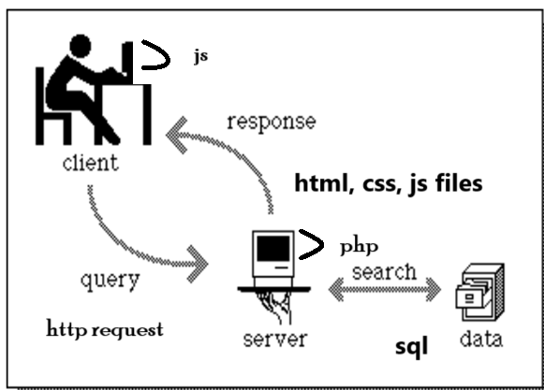
In this project, you will learn full-stack development and how to create a fully functional web application using HTML, JavaScript, CSS, PHP, and MySQL. The code will be stored on a server, and client-side browsers will request and render these pages. You will install XAMPP, which includes Apache (a local server) and MariaDB (a database). You will create a login page, registration page, and profile page, and develop a database to store user information.
XAMPP is chosen for its simplicity and ease of setup, making it ideal for beginners and intermediate developers. It provides a pre-configured environment to host web applications locally, eliminating the need for manual configuration of individual components. However, other full-stack development frameworks are widely used in industry and offer advanced capabilities. For example, the MEAN stack (MongoDB, Express.js, Angular, and Node.js) and the MERN stack (a variation replacing Angular with React) are popular for developing scalable and efficient web applications. These stacks leverage JavaScript across both front-end and back-end development, making them highly cohesive and suitable for modern, real-time applications. Python based enviroments include Django / Falsk.
Additionally, cloud-based platforms like AWS (Amazon Web Services) are gaining traction for hosting and deploying web applications. AWS offers services such as EC2 (virtual servers), RDS (managed databases), and S3 (object storage) that allow developers to build and scale applications efficiently. While cloud-based solutions are more powerful and versatile, they can introduce complexity and costs that may not be ideal for smaller projects or learning environments.
For this project, XAMPP is used to provide an accessible, local development environment where you can focus on fundamental full-stack development concepts without the overhead of managing cloud infrastructure.

The project is divided into three parts:
PART 1: You will create the HTML, CSS, and JavaScript files for page rendering, along with PHP files for server-side programming and database manipulation. This will include designing and implementing a database to store user information.
PART 2: You will integrate HTML code into PHP files. While PHP is powerful due to its ability to interleave HTML and PHP code, this can also introduce complexity and clumsiness. You will also learn about session management in this part.
PART 3: You will explore common web vulnerabilities, such as SQL Injection, and learn techniques to mitigate these risks.

PART-1:
You will learn:
- How to write front end interactive wep pages(STEP-0)
- How to create a local web and SQL server on your machine (STEP-1)
- How to upload a web page to the local web server & test (STEP- 2)
- How to create a web database (STEP-3)
- How to use a server-side program (STEP-4)
- How 3-tier architecture works in web environment (STEPs 0 -4)
- The importance of one-way hash functions in passwords
You will install a local web server and create:
- HTML scripts login.html and register.html using HTML, CSS, and JS (Client-side program)
- A simple database
- Server-side programs login.php and register.php (using PHP and embedding MySQL code)
There are three tasks.
[Task-1 (30 points) + Task-2 (20 points) + Task-3 (40 points) + Overall - including XAMPP, MySQL DB (10 points]

PART-1 : DELIVERABLES ZIP all the following files into one document before submitting.
Task-1 (Client-site programmin)
- login.html (given)
- register.html (including CSS styles and JS script- if any)
- validation Screen shots:
  - screen shots of the registration web-page image with some invalid input values & error messages
Task-2 (Database)
- All the table structures (screenshots)
- All the table data (screenshots)
- Screenshot showing relations
- Exported sql file (will include all 4, 5, and 6)
Task-3 (Server-site programming)
- register.php
- screen shot of the registration web-page image with a valid record
- Screen shot of the member and memberPW tables before and after submitting a new record (showing the new record as one of the rows in the member table after storing new record from the form)
- Exported database file with and without new record (acm1.SQL / acm2.SQL files)
- login.php
- Screenshots of successful and unsuccessful login (for new record)

STEP-1: Installing a Local Web Server
Install XAMPP
- XAMPP is a free and open-source cross-platform web server solution stack package developed by Apache Friends, consisting mainly of the Apache HTTP Server, MariaDB database, and interpreters for scripts written in the PHP and Perl programming languages.
Download and install XAMPP from XAMPP's official website. (book pg 611-613, section 17.6)
Download XAMPP
XAMPP for MacOS - XAMPP
How to Install XAMPP on Linux (with Pictures) - wikiHow
- Once installed, the XAMPP control panel will be started – start the Apache server and MySQL server from the XAMPP control panel.
If xampp control panel is not opened automatically, go to the folder c:\xampp (usually xampp is installed in this folder)
Instead of xampp_start.exe, you may run xampp_control.exe.
You will get a screen like the following image:
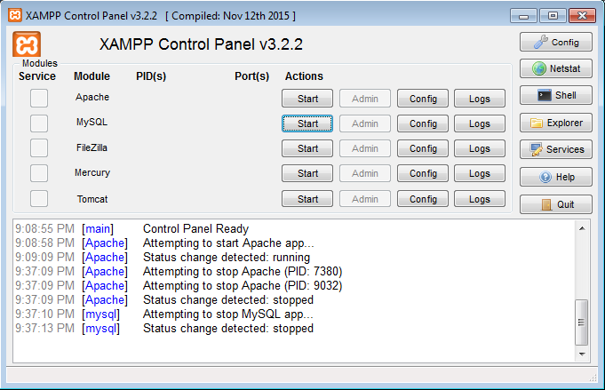
Image-1

Start Apache and MySQL (chapter 18).
The control panel will reflect the changes.
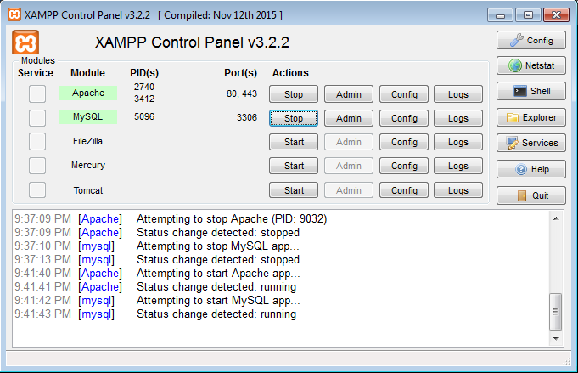
Image-2

Now you have a local web server and on which mysql is running on the background.
Test your setup Open a browser, and type localhost on the address bar. (see section 17.6.3)
You should get web page like the following (yours may be slightly different).

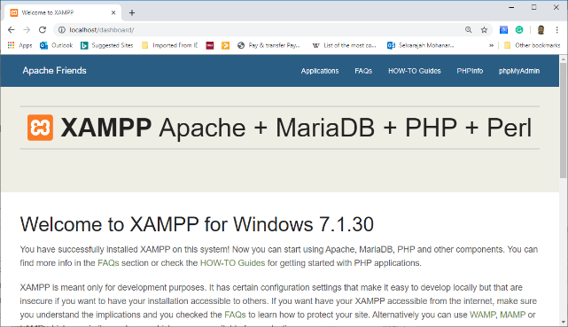
Image-3

STEP-2: Uploading web pages to a web server (Example:upload login.html to your local web server)
Web server root: c:\xampp\htdpcs will be considered as the web root in XAMPP.
In VSCode, File Add Folder to Workspace select the folder c:\xampp\htdpcs. The subfolder c:\xampp\htdocs will be considered as your web root. The web pages stored in this directory can be accessed from outside the server using a client browser by typing htpp://localserver on the address bar.
Use VSCode- create a folder for Project-Part-1 (say CSC3800PP1) in htdocs.
Save the following html document in htdocs/CSC3800PP1 as login.html.
<!DOCTYPE html>
<html lang="en">
<head>
<meta charset="UTF-8">
<meta name="viewport" content="width=device-width, initial-scale=1.0">
<title>Document</title>
<script>
window.onload = function() {
const urlParams = new URLSearchParams(window.location.search);
const msg = urlParams.get('msg');
const err = urlParams.get('error');
if (msg)
document.getElementById('msg').textContent = msg;
if (err)
document.getElementById('error').textContent = err;
}
</script>
</head>
<body>
<p id="error" style="color:red;"> </p>
<form action ="login.php" method="post">
<table>
<tr> <td> User name: </td>
<td> <input name= "uName" type="text" required> </td> </tr>
<tr> <td> Password : </td>
<td> <input name="pw" type="password" required> </td> </tr>
<tr> <td> <input type = "submit"> </td>
<td> <input type="reset"> </td> </tr>
</table>
</form>
<hr/>
<p id="msg"> if you are new, you have to <a href="register.html"> register </a> here </p>
</body>
</html>

image-4
Ignore the JS code (window.onload) now.
You should be able to understand the code in html form.
Now open a browser, and type localhost/CSC3800PP1/login.html [Note that, VSCode Live Server extension is good for rendering static pages. Since we are going to use dynamic pages, we will directly open a web browser and type the appropriate URL starting with localhost]
You will get a screen like the following:
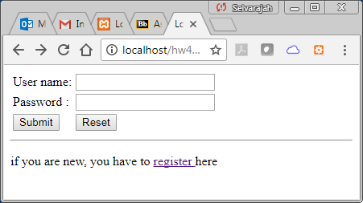
image-5

###############################################################################
CHECKPOINT-1:
On the log-in web page (see image-5), If you click on the hyperlink register, you will get a server-side error (Error 404 – Object Not Found).
There is an anchor element with an opening tag as <a href="register.html"> (Check the corresponding html code in image-4. )
The hyper link on the anchor text “register” links to the file register.html. Since register.html is not available on your server (htdocs/csc3800PP1), you get the above error from server. Note that, now you only have login.html on your server.
You will now create this missing web page register.html in PP1-: Task-1, and upload to the server. Note that, there are no username+password records exist on the database now. This html form will be used to get those informations from the users and later we will use a php program (to be created) to insert these new records to the DB (to be created).
################################################################################

PP1 : TASK- 1 [client-side programming] (30 points)
You are required to write the missing html document register.html and upload it to your web server’s home directory (store it in htdocs/csc3800PP1). The register.html should be rendered on the browser like the image-7. You may include appropriate inline/embedded CSS styles.
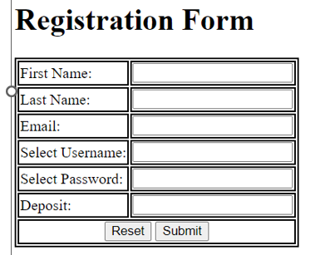
Image-6
All the fields in the form should be declared as “required”. Appropriate input types should be selected (e.g. email, password). The opening tag of the form element in your register.html document should look like the following.
<form action ="register.php" onsubmit="return validate()" method="post">
Note that, the above form element includes an attribute onsubmit with the value “return validate()”. When the register.html page is submitted, a JS function should first validate the form input to make sure that the input data is valid (for this assignment, check at least the first name and last name contain alphabetical characters only [check the JS code below], and also check the given email is a uncp email address [hint: you may use substring() and lastIndexOf() to extract the domain in the email address]. (also check hw-3: part-3: in this assignment we avoid using confirm.html)
https://www.w3schools.com/js/js_validation.asp
See the code below] /^[A-Za-z]+$/ can be used to match an input string of ASCII alphabets. You can also use VScode-regex: install regex (regular expression) extension.
- [A-Za-z] will match all the alphabets (both lowercase and uppercase).
- ^ and $ will make sure that nothing but these alphabets will be matched.
Try to understand the partial html/css/js code in image-7 for the register,html- ignore window.onload function. Complete the code.
VERY IMPORTANT: Include a comment in register.html just after the <body> tag: “This page is created by <your name> on < date> “
<!DOCTYPE html>
<html lang="en">
<head>
<meta charset="UTF-8">
<meta name="keywords" content="ACM">
<meta name="viewport" content="width=device-width, initial-scale=1">
<title>ACM Registration Page </title>
<style>
table, tr, td {
border: 2px solid black;
}
</style>
<script>
function validate() {
var letters = /^[A-Za-z]+$/;
var lastname = document.getElementById("fname").value;
if(!lastname.match(letters)) {
alert("Not a valid First Name");
return false;
} // COMPLETE THE REST
return true;
}

image-7
window.onload = function() {
const urlParams = new URLSearchParams(window.location.search);
const msg = urlParams.get('msg');
if (msg) {
document.getElementById('msg').textContent = msg;
}
};
</script>
</head>
<body>
<!---This page is created by Mohan-->
<h1>Registration Form </h1>
<p id="msg" style="color:red;">
If you already have an account, <a href="login.html">login here</a>
</p>
<form name ="myForm" onsubmit="return validate()" action = "register.php" method="post">
<table>
<tr>
<td><label for="fname">First Name:</label></td>
<td><input type="text" id="fname" name="fname" required></td>
</tr>
<tr>
<td><label for="lname">Last Name:</label></td>
<td><input type="text" id="lname" name="lname" required></td>
</tr>
<tr>
<td><label for="email">Email:</label></td>
<td><input type="email" id="email" name="email" required></td>
</tr>
<tr>
<td><label for="username">Select Username:</label></td>
<td><input type="text" id="username" name="username" required> </td>
</tr>
COMPLETE THE REST

</body>
</html>

Upload register.html to your web server’s home directory (store it in htdocs/csc3800PP1). Now, if you type localhost/csc3800PP1/login.html on a browse you should get a page like image-6.

Deliverable for Project:Part-1: Task-1:
(1) register.html
(2) registration web-page screen shot (like image-6 with some invalid input values) & appropriate error messages (image- 8), for name and email- similar to the image below - at least two screen shots.
(3) a valid record- before submitting
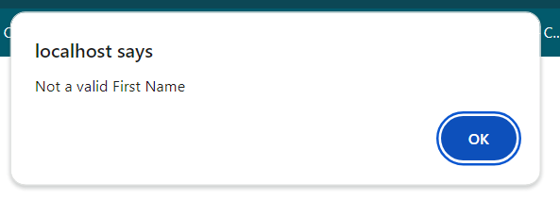image-8

##############################################################################
CHECKPOINT-2:
Now, test this registration web page again with some valid values and click on submit.
You will get the server-side error (Error-404 Object Not Found).
This is because, when you submit the form, the value of the action attribute in the opening tag of the form element will be executed (see the action attribute in the above form’s opening tag below).
<form action ="register.php" onsubmit="return validate()" method="post">
Since register.php is not in your web server (htdocs/csc3800PP1), you will get the above error.
You will write register.php in PP1:Task 2 (will be explained later- after you create the database in next section). Once created, you have to upload register.php to your local web server (htdocs/csc3800PP1).
Before writing register.php, we have to create a database on the server to store the information submitted from the form.
The registration form includes personal details and login details. For security reasons we will keep two separate tables to store both details. We will create two tables named mebersPW and members to store the login and personal details respectively. We will let the DBMS create a unique member number for each new member. In RDBMS (relational- DBMS), this member number is called the primary key for the member’s table. This member number will be included in the memberPW table as a foreign key to link both records. Check two mock-up records in the tables below. Ray Kemp’s user name is Ray. If you give the user name Ray and the corresponding password (here encrypted) you can log in as Ray Kemp.
members Table
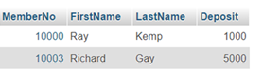

membersPW Table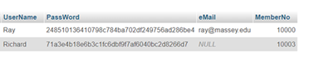
PP1 : TASK- 2 [Creating a Database] (20 points)
In this section, we will
- create a database in MySQL under XAMPP environment
- create a table named membersPW and include 2-3 mockup data (user name, password, and email)
In task-3, you will create a server-side program login.php and use the client-side program login.html and this table to test the login functionality.
(Create later- explained under Task-3)
- Create a table named members and include the rest of the mockup data (first name, last name, and deposit). Make sure to match the auto generated member number.
- Link the primary key of membersPW table (MemberNo) with the foreign key of members (MemberNo) [ignore this: usually the members table will have primary key]
In Task-3, you will write a server side program register.php to store the given data in the registration form (registration.html) to this table in the dB

###############################################################################
Creating a Database on your local web server
- For a video tutorial, see https://www.youtube.com/watch?v=pmh6aasUulI
In XAMPP control panel, click on ADMIN in the MySQL row.
OR, type localhost/phpmyadmin on a browser (see image-9). phpMyAdmin is a free software tool written in PHP, intended to handle the administration of MySQL over the Web.
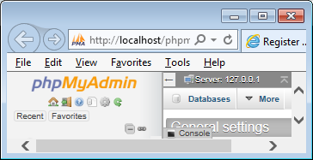
Click on Databases
Image-9

Now we will create a MySQL database. Click on the tag Databases. Type a name for the database in the create database text box and click on <create> (here ACM???? is given in image-10).
VERY IMPORTANT: You have to give the name of the DB as ACM???? - where ???? is the last 5 digits of your banner id.
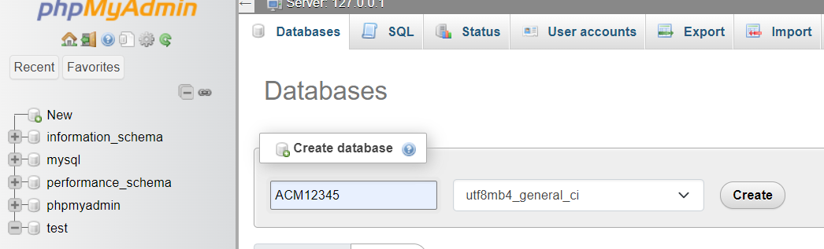
Image 10
Now we will create a table to store member’s password. Give a name to the table, say membersPW; we need 4 columns (for UserName, PassWord, eMail, and MemberNo): type 4 for the number of columns. Click on <GO> (see image- 11). Later, we will create another table called members to store other information such as first and last names).
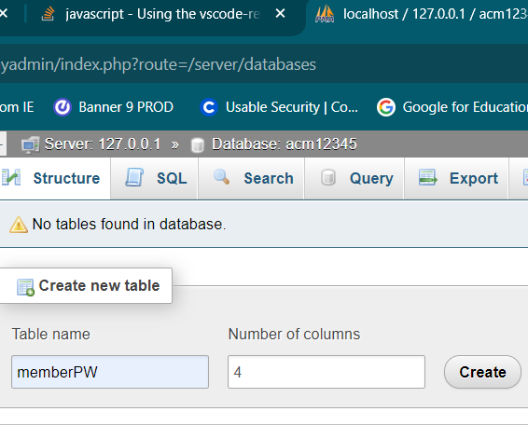
Image-11

Now, we will declare the structure of the table named members. Give names, types and other attributes for the columns (UserName, PassWord, eMail, and MemberNo), and save (on bottom).
Check the image-12 carefully. Note that I selected A-I (auto increment) for MemberNo and null (may be null) for eMail. UserName is unique. This approach ensures that: memberno uniquely identifies each record, and username remains unique but is not part of the primary key, making it easier to change if necessary.

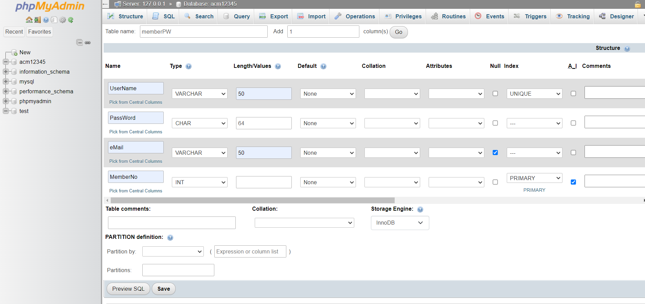
Image-12

After saving, you will get the next screen (image-13). Make sure MemberNo is selected as the primary key and UserName as an index (click on more – check image-13). Primary key uniquely identifies a row in a table and indexing is helpful for fast searching.
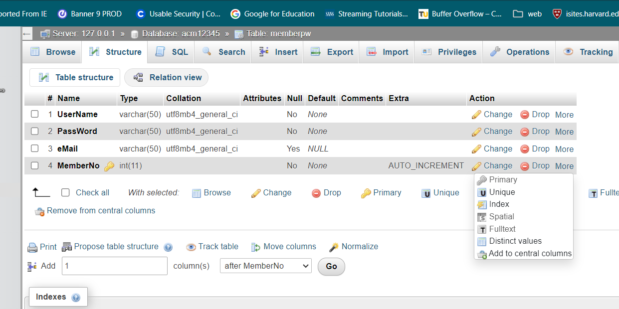
Image-13
For security purpose, password should not be stored in plain text. For this assignment SHA-1 will be used as one-way hash function. Please check the following link or other web sites to learn more about hashing and salting: http://security.blogoverflow.com/2013/09/about-secure-password-hashing/
Now, we will include some mock-up data in the memberPW table. I typed two records and pressed GO (the last). Select SHA-1 function for password. I gave the first member number as 10000. For the second record I did not give the member number- it will be automatically generated\incremented by MySQL. You may leave email null.
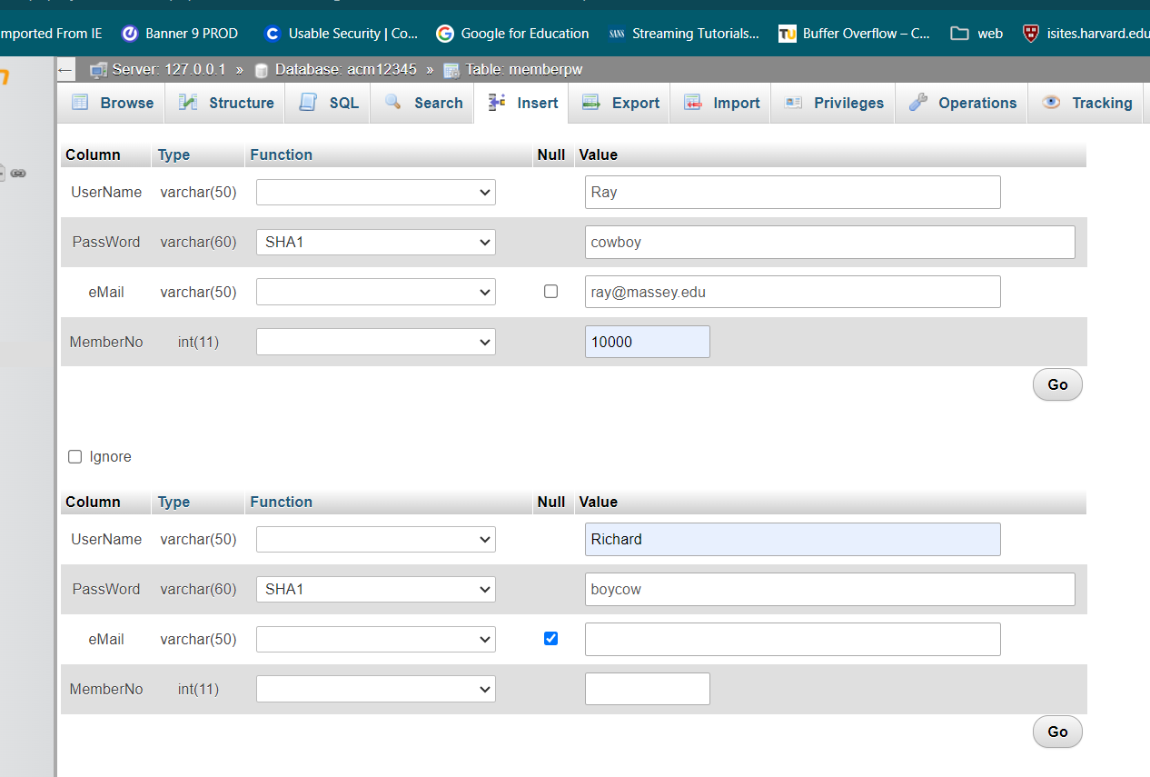
Image-14
Now select Browse on the menu bar and view the table (image-15). You can see both records. You can see that the passwords are hashed.
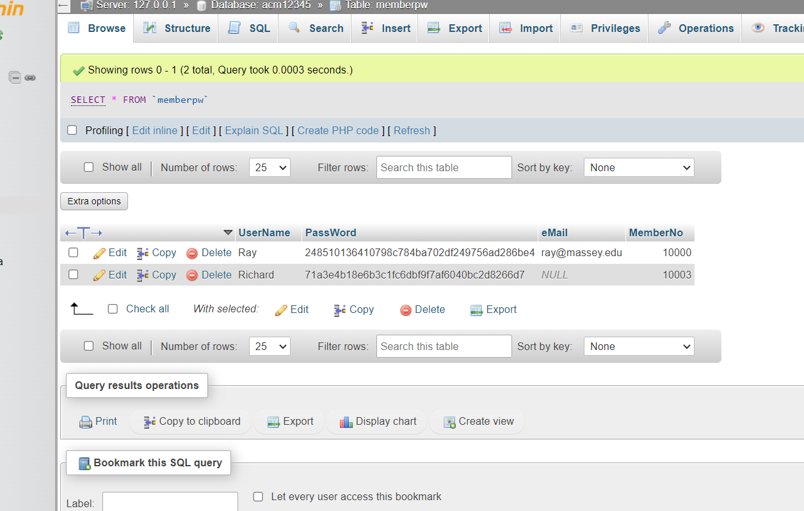
Image-15
Now add one more record with username ‘Selva’. The password will not be given to you, but its hash value will be available (sha-1 hash of the password is c60266a8adad2f8ee67d793b4fd3fd0ffd73cc61). One of your task in Project-Part-3 is to crack this password (will be discussed later in Part-3). A hint is that the password is selected from the same common table http://security.blogoverflow.com/2013/09/about-secure-password-hashing/
To store the hashed password without knowing the original password, copy and paste the above hashed value in the password field- but do not select SHA-1 (to avoid double hashing). See image-16 and Image-17. Your MemberNos may be different.
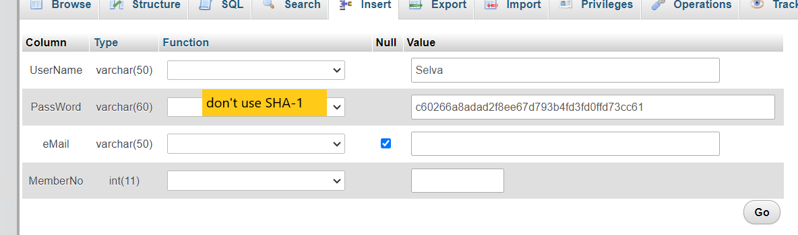
Image-16
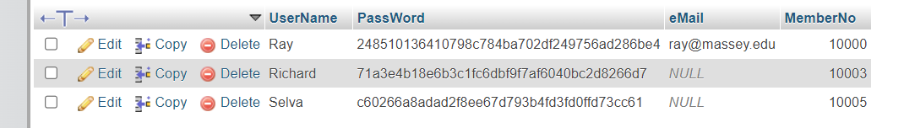
Image-17
You need to include 3 more mock-up records. Press Insert on the menu bar. For the password, you have to select SHA-1 as the hash-function. Press <GO> to save the rows in the table.

###############################################################################
CHECKPOINT-3
Now we will get back to the login page in image-5 [ if the page is not opened, type localhost/csc3800PP1/login.html on a browser].
Type the username as Ray and password as cowboy, and then click on <submit>.
You will get the same server-side error again (Error-404 Object Not Found).
This is because, when you submit the form, the value of the action attribute in the opening tag of form element will be executed (see below html code snippet from image-4).
<form action ="login.php" method="post">

Since login.php is not in your web server (htdocs/csc3800PP1), you will get the object-not-found error. Obviously, when the form is submitted, the user name and password pair should be checked against the data base in the server side. The server side program “login.php” should perform this task.
In the next section, we will learn how to write login.php.
Once created, you have to upload login.php to your local web server (in VSCode create a file on the folder htdocs/csc3800PP1).
###############################################################################

Task-2 (Database)
- All the table structures (screenshots): membersPW and members
- All the table data (screenshots): membersPW and members
- Screenshot showing relations: membersPW members
- Exported sql file (will include all 4, 5, and 6)- see instructions later

PP1- Task 3: Server side Programming using PHP [40 points]
When a form is submitted, the value in the action attribute in the form tag will determine the next action. In the login.html (image-5), the following tag is included:
<form action ="login.php" method="post">
When the form is submitted, the user name and password pair should be sent from the client’s browser to the server side in order to authenticate the user. In this example, the server-side program “login.php” should get the username-password pair and check against the stored values in the database.
We already created the database (with a single table). The PHP code given in image -18 will check the user name and password in the database. If the password is correct, the user’s full name will be displayed on the client-side browser’s screen. Store this code as login.php on your web server (htdocs/CSC3800PP1). Make sure to change $db=”ACM????” With your DB name, and fill-in two blanks ??? with suitable variable names.
IMPORTANT: The given program is not secure. It is not using sessions. Also, a malicious person may use SQL injection to login to the system without knowing any user name or password [see Task-3 in Part-2].
Note that, there are three variable names used for user name and passwords in this program; for example, for user name, uName is used in HTML form (see login.html <input name= "uName" ), $uName1 is used in PHP (see login.php $uName1 = $_POST['uName']; ), and UserName is used in MySQL column (see image-12). If you prefer, you may use same names in all places; HTML, PHP, and MySQL.

If we use VS Code with PHP, first, we have to setup VS Code with PHP Extensions
- Install PHP Intelephense extension in VSCode
By default, VS Code may use a different PHP installation (or none at all). By default, VS Code may use a different PHP installation (or none at all). Once installation is complete, Intelephense’s official documentation recommends that you disable the built-in PHP Language Features extension that comes with VS Code. To disable this extension, type @builtin php in the Extensions search box to locate the built-in PHP extensions. Then click on the settings icon for the PHP Language Features extension, and click the Disable option in the drop-down menu.
[or, we must tell VS Code to use XAMPP’s PHP. Press Ctrl + Shift + P to Open VS Code Settings (JSON); Type "Preferences: Open Settings (JSON)"; Press Enter; Add this setting inside the JSON file, add the following line: "php.validate.executablePath": "C:\\xampp\\php\\php.exe"]
- Later, you can install and configure VSCode Debug extension (get help from a LLM)
Image-18
//Fill-in all places marked as ??? with suitable PHP code segments.
//we keep some values for the environment variables such as db name in this code- but, best practice // is storing them in an *.env file- see end of this document
<?php
//Get the data from the client side HTML form
$uName1= $_POST['uName']; // get the user name from the form field uName
$pw1 = $_POST[???]; // get the pw from the HTML form field pw
//GLOBAL VARIABLES
$memberNo1; $conID; $db;
//Functions
function openDatabase(&$conID, &$db){ //to create a handle $conID for the database
$host = "localhost"; $db = "ACM12345"; $usr = "root"; $pw =""; // change 12345 with last 5 digits of your banner-id
$conID = new mysqli($host, $usr, $pw, $db);
if ($conID->connect_error) {
die("Connection failed: " . $conID->connect_error);
}
}
function pwOK($conID, $uName1, $pw1, &$memberNo1){
$SQL = " SELECT * FROM memberPW";
// the given password is encrypted before matching with the password in database
// make sure the column names in the DB table matches, here UserName and PassWord
$SQL = $SQL . " WHERE UserName = '???' AND PassWord = sha1('$pw1')";
$result = $conID->query($SQL);
if (!$result) {
die( "Query Error: " .$SQL. " :" .$conID->connect_error); // insecure output
} else {
$row = $result -> fetch_array();
if (!$row){ // if the row is empty, user name, password pair is wrong
return false;
} else {
$memberNo1= $row['MemberNo']; //should match table's column name
$result->close();
???;
}
}
}
// MAIN
// MAIN
openDatabase($conID, $db);
if (pwOK($conID,$uName1,$pw1,$memberNo1)) {
echo "<h1> Welcome Member, Member Number:". $memberNo1. substr($db,3) . " </h1>";
} else {
header('Location: login2.html?msg="User name or password is wrong- Try again"');
}
$conID->close();
?>

Once created, upload login.php to your local web server (create the file on htdocs/csc3800PP1)
Now test the log-in function.
Type localhost/csc3800PP1/login.html on a browser, and try the username (Ray) and password (cowboy).
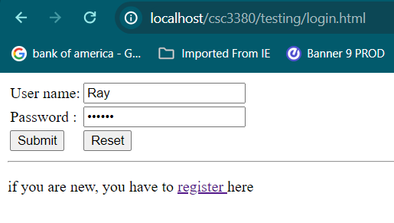image-19
Password is cowboy

When <submit> is pressed you will get a new page similar to image-20 (last 5 digits should come from your banner-id).
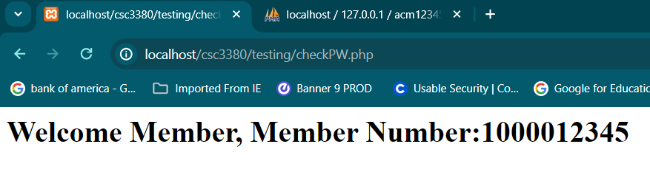
Image-20
But, If password or username is wrong, the login page will be displayed with appropriate message.
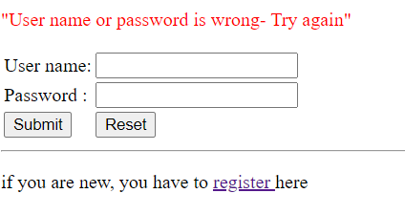
###############################################################################

Navigation Diagram
login.html
msg: if new, register
login.html
msg: registered- now login
login.html
err: wrong- re enter msg: if new, register
register.html
msg: none
memberInfo.php
(later)
register.html
msg: username taken
new -register
username exists
username exists
registration success
registration
success
wrong un or pw
wrong un or pw
wrong un or pw
login success
login success
login success

Note that, there are three initial screens/states for login.html with different messages, and similarly register.html has two states. The JS code in window.onload() function is used to handle this feature.
Try the following URLs and see the difference;
localhost/csc3800pp1/login.html
localhost/csc3800pp1/login.html?msg=”msg test”
localhost/csc3800pp1/login.html?err=”err test”
localhost/csc3800pp1/register.html
localhost/csc3800pp1/register.html?msg=”msg test”

CHECKPOINT-4
As we mentioned before, Ray’s password is ‘cowboy’ (this is the 100th most popular passwords (checked on 9/10/2019)- see http://www.passwordrandom.com/most-popular-passwords ), which was encrypted by SHA-1 and stored as 248510136410798c784ba702df249756ad286be4. As mentioned before, Selva’s password was also selected from the same table. It was encrypted by SHA-1 and stored as c60266a8adad2f8ee67d793b4fd3fd0ffd73cc61. Type localhost/csc3800PP1/login.html on a browser and if you try the username (Selva) and the original password (you don’t know this yet) you will get the page like image-21.
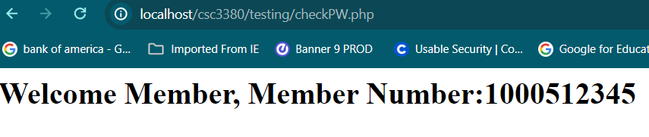
Image-21
One of your tasks in Project-Part-2 is to crack Selva’s password (will be discussed later in PART-3).

###############################################################################
register.php
Now, you are required to write the server-side program register.php to store new members’ details in the data base (a part of the program is given in image-20: you can fill in the blanks or write your own program from scratch- first, review the program login.php in image-16).
First, we need to create another table to store the first name, last name and deposit. We also need MemberNo to link both tables.
Create a table Members (see Image 22). Make MemberNo as a primary key. Don’t select this as A-I. In memberPW table MembrNo was selected as A-I. In Members table we will use this auto generated member number (see later in the program $lastMemberNo = $conID->insert_id; is used to get the auto generated member number from the DBMS)

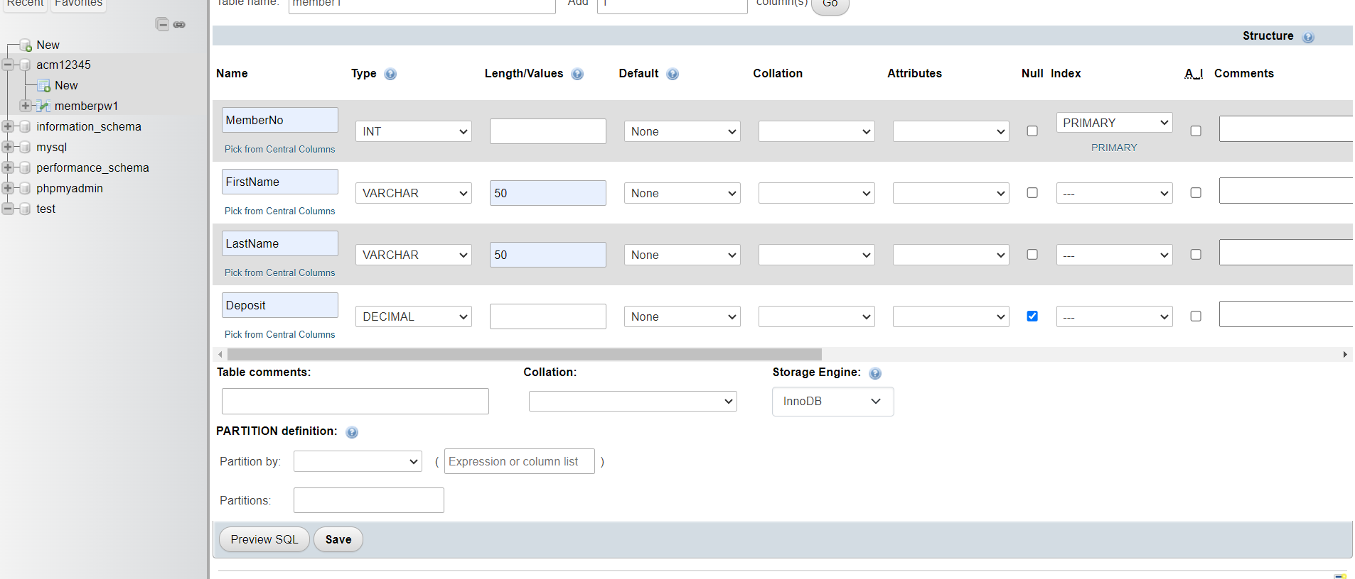
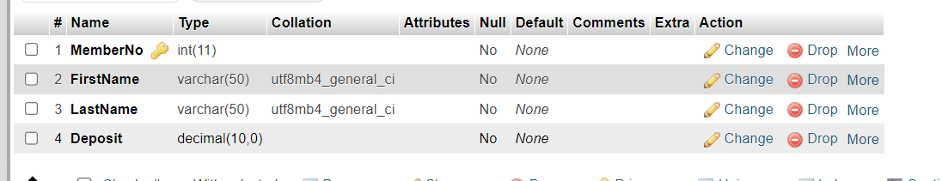
Image-22

We can link both tables MemberPW and Member using MemberNo in PhpMyAdmin. Select Member table, Structure, and Relation View (see Image 23).
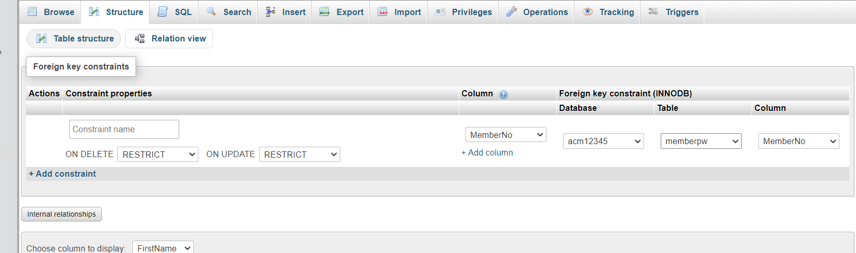
Image-23
Remember we manually added three members in MemberPW table. We need to manually add some missing information in the Member table.
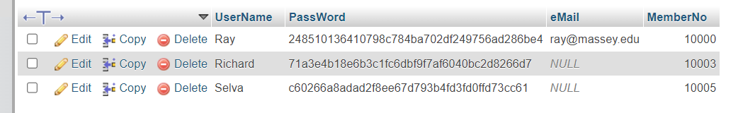
If we link both tables properly, the value cell will give a pull-down menu with the available member numbers.

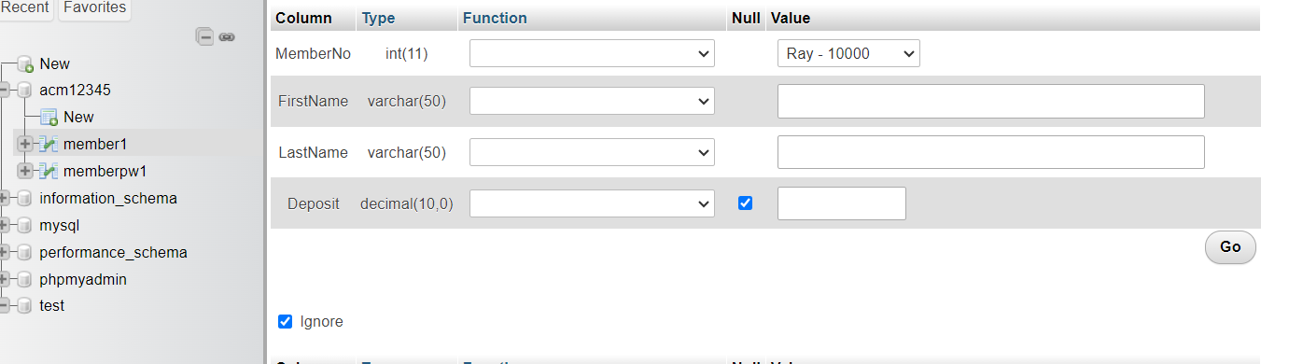.
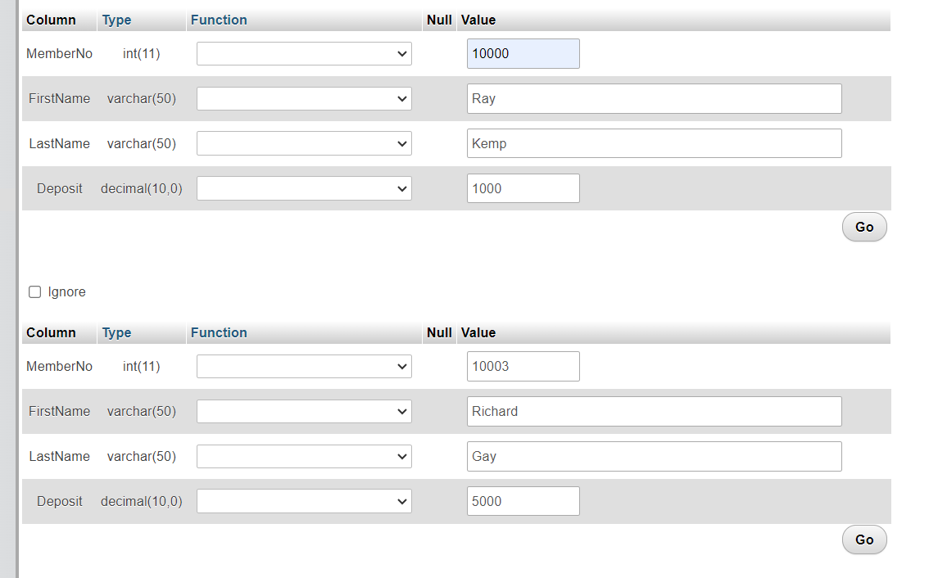
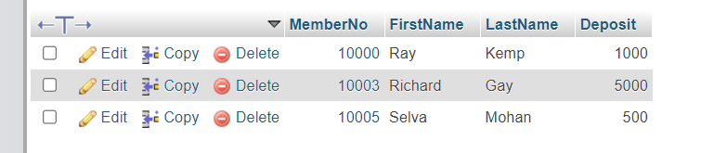
Image-24
As mentioned before, you are required to write the server-side program register.php to store new members’ details in the data base (a part of the program is given in image-25: you can fill in the blanks or write your own program from scratch
Create register.php in your web home directory htdocs/csc3800PP1.
In Project:Part-1: Task-1 you have created register.html to get data from the user.
<form name ="myForm" onsubmit="return validate()" action = "register.php" method="post">
When the user submits the completed form, your program should first check the given user name is not taken by any other members. If so, the registration form should be displayed again with appropriate message (better to retain all other data except the user name). Now check the code in window.onload function in register.html.
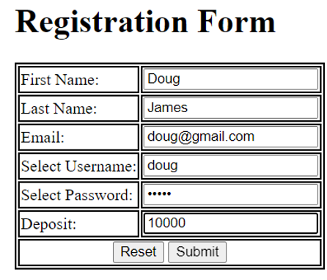 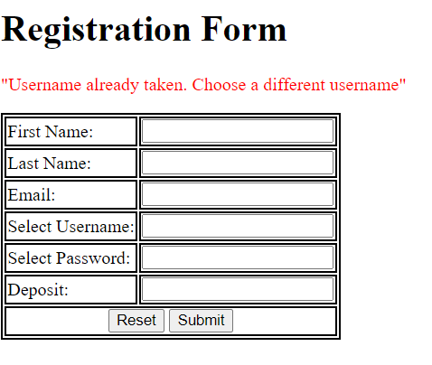image-25
Store all the information on the form in the server-side database ACM (in the tables MemberPW and Member). The member no will be generated first while storing in memberPW table and will be used in member table. After storing the information, the login page should be displayed with appropriate confirmation message (compare the login pages before and after registering (image-26). Now check the code in window.onload function in login.html.
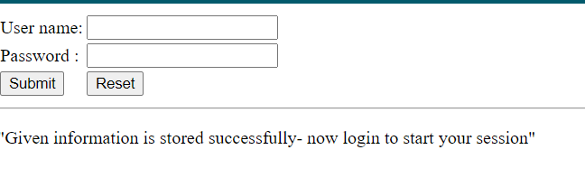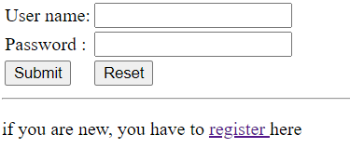
image-26
You can check the database tables to make sure all the information are stored properly (see image 27).
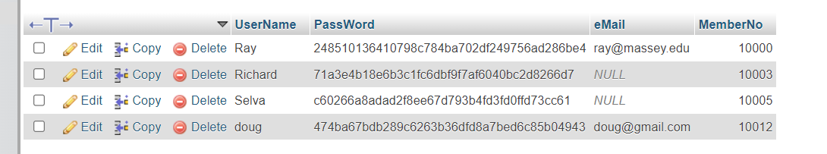
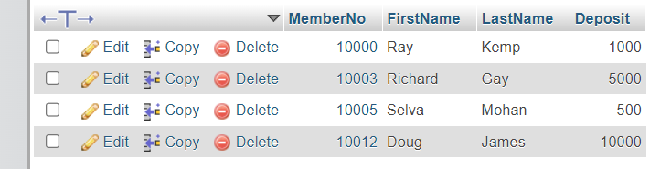
Image 27.
Fill-in all places marked as ?? with suitable PHP code segments.
<?php
if ($_SERVER["REQUEST_METHOD"] == "POST") {
// Get form data
$fname = $_POST['fname'] ?? ‘ ’; //check the names in the HTML form

//complete this

}

//GLOBAL VARIABLES
$conID;
// Database connection
function openDatabase(&$conID){ //to create a handle $conID for the database
// complete this
}

function usernameTaken($conID, $uName){
$sql = "SELECT * FROM memberPW1 WHERE UserName= '$uName' ";
$result = $conID->query($sql);
return $result->num_rows > ???;
}

function write($conID, $fName,$lName, $eMail, $uName,$pw, $deposit){
// Insert data into database
$hashed_password = ???($pw); // password_hash($password, PASSWORD_DEFAULT);
$sql = "INSERT INTO memberPW (UserName, PassWord, ???)
VALUES ('???', '$hashed_password', '$eMail')";
if ($conID->query($sql) === TRUE) {
$lastMemberNo = $conID->insert_id; // to get the auto generated member number
} else {
echo "Error: " . $sql . "<br>" . $conID->error;
return false;
}

$sql = "INSERT INTO member1 (MemberNo, FirstName, LastName, Deposit) VALUES ('$lastMemberNo', '$fName', '$lName', '$deposit')";
if ($conID->query($sql) === TRUE) {
echo "New member record created successfully.";
} else {
echo "Error: " . $sql . "<br>" . $conID->error;
return false;
}
return true;
}

// MAIN - This program is written by <your name> on <give date>
openDatabase($conID);
if (usernameTaken($conID,$username)){
header('Location: register.html?msg="Username already taken.
Choose a different username"');
exit;
}

if (write($conID,$fname, $lname, $email, $username, $password, $deposit)) {
header('Location: login.html?msg="Given information is stored successfully- now login to start your session"');
}
?>

Deliverables for PP1: Task-2
- register.php
- screen shot of the registration web-page image with a valid record- before submit
- Screen shot- registration confirmation
- screen shots of the member and memberPW tables before and after submitting a new record (showing the new record as one of the rows in the both tables after storing new record from the form)
- Exported database file with and without new record (acm1.SQL / acm2.SQL files)
- login.php
- Screenshots of successful and unsuccessful login (for new record)

Exporting a database
- Open and log into phpMyAdmin.
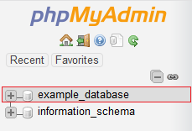
- Select the source database on the left pane.

- Click on the Export tab in the top center pane.
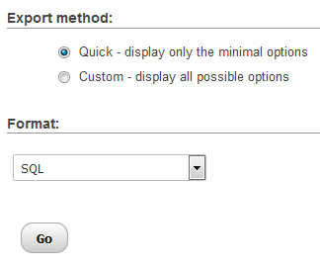
- On the next page you must select a Quick or Custom export method.

Choosing the 'Quick' method allows you to download the .sql file immediately. The 'Custom' method gives you more control over the data. Only use the 'Custom' method if you're very familiar with managing SQL tables.
- From the dropdown menu, choose the format you'd like to save the file as. SQL is most common.
- Click the Go button to continue.
- A pop-up displays allowing you to download the file. (Note: your browser may also download it automatically.)

Environment Variables

We hardcoded some environment variables in many php programs.
For example:
<?php
function openDatabase(&$conID, &$db){ //to create a handle $conID for the database
$host = "localhost"; $db = "ACM12345"; $usr = "root"; $pw ="";
$conID = new mysqli($host, $usr, $pw, $db);

But, best practice is retrieving from an external text file (say acm.env) in the server.

ccm.env

MYSQLUSR = "testUSR"
MYSQLPASS = "testPW"
MYSQLDB = "acm12345"

<?php
function loadEnv($path)
{
if (!file_exists($path)) {
return false;
}

$lines = file($path, FILE_IGNORE_NEW_LINES | FILE_SKIP_EMPTY_LINES);
foreach ($lines as $line) {
if (strpos($line, '=') !== false && strpos($line, '#') !== 0) {
list($key, $value) = explode('=', $line, 2);
$key = trim($key);
$value = trim($value);

// Remove quotes if present
if (preg_match('/^(["\'])(.*)\1$/', $value, $matches)) {
$value = $matches[2];
}

$_ENV[$key] = $value;
putenv("$key=$value");
}
}
return true;
}

// Load .env file from project root
loadEnv(__DIR__ . '/../csc3380pp1/.env');

//Functions
function openDatabase(&$conID, &$db)
{ //to create a handle $conID for the database
$host = $_ENV['DB_HOST'] ?? "localhost";
$usr = $_ENV['MYSQLUSR'];
$pw = $_ENV['MYSQLPASS'];
$db = $_ENV['MYSQLDB'];
$conID = new mysqli($host, $usr, $pw, $db);

